PTC Fast- Parent View
1. Enter web address in the letter or link from the PASD webpage.
The screen will look similar to:
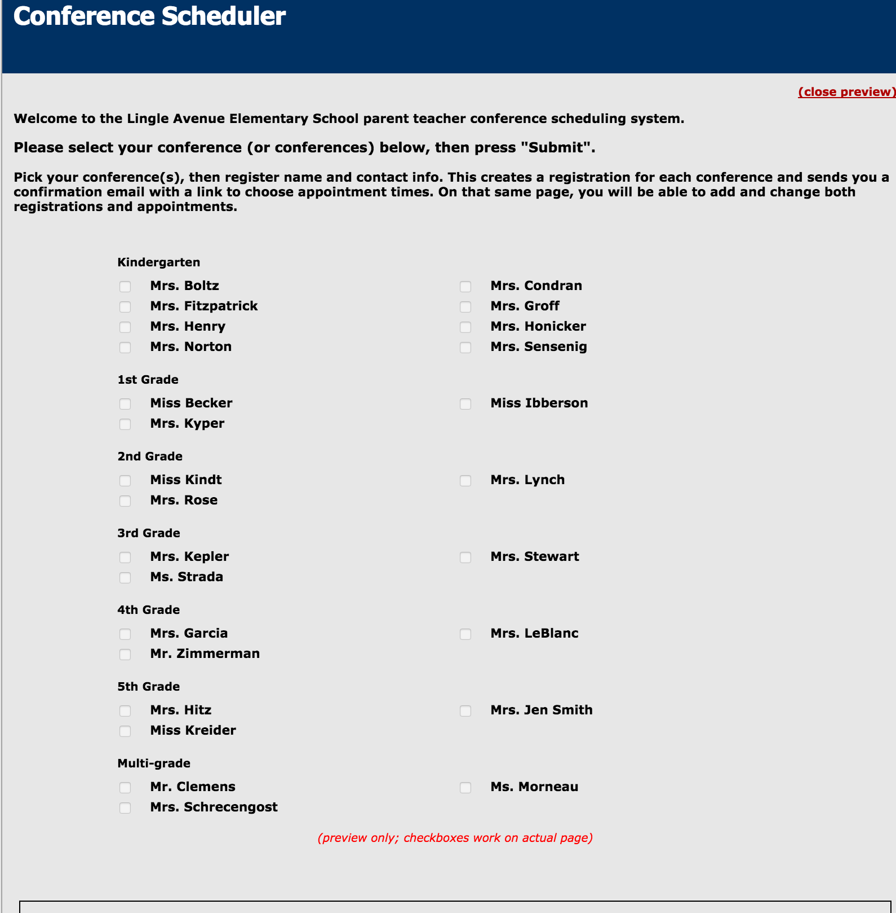

2. If you have used the system before, follow the prompt to login using your email, If you have a different email or have not registered before, click on the name of your child's teacher.

3. You will be prompted to register for the PTC system and must provide a valid
email address.
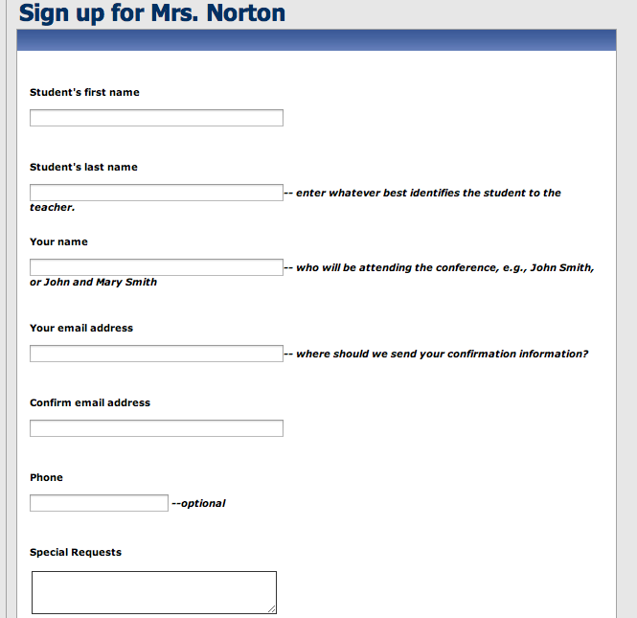

4. A link will be sent to your email account. After you click on the link from the PTC email sent to your account, you will be brought to another screen to select your time. *If you have another child in the same elementary building, click "Add a different student". You will register your other student and will be brought back to this screen. Check in the box next to the preferred time and hit "confirm selection".
(The screenshot below is an example of the times and does not reflect the accurate dates and times for conferences).
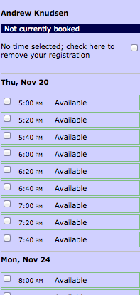

5. You will be sent an email reminder to confirm your time.
