Governor Wolf’s Employment First Policy to Help People with Disabilities Find Work Becomes Law
June 19, 2018
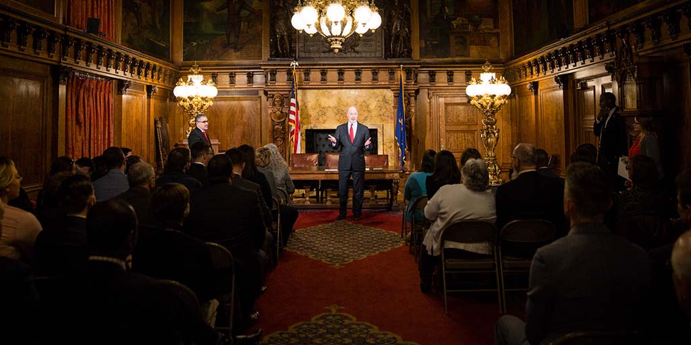
BILL SIGNING, GOVERNMENT THAT WORKS, JOBS THAT PAY, PRESS RELEASE
Harrisburg, PA – Governor Tom Wolf today signed House Bill 1641, codifying the Employment First policy that the governor established by executive order in March 2016 to increase competitive employment opportunities for people with disabilities.
“My executive order two years ago focused Pennsylvania on being a model state that is hospitable to workers with disabilities and I’m proud to sign this bill adding the weight of law,” said Governor Wolf. “This is a win-win for Pennsylvania. Our employers need smart and skilled workers and increasing employment opportunities ensures people with disabilities can achieve greater independence and inclusion in our communities.”
House Bill 1641, sponsored by Rep. Bryan Cutler, creates the Employment First Act requiring state, county, and other entities receiving public funding to first consider competitive integrated employment as the preferred outcome of publicly funded education, training, employment, and related services, and long-term services and support for individuals with a disability who are eligible to work under state law.
The statue also creates the Governor’s Cabinet for People with Disabilities and the Employment First Oversight Commission. The Governor’s Cabinet for People with Disabilities will review existing regulations and policies to recommend changes to laws, regulations, policies, and procedures that ensure implementation of Employment First. The Employment First Oversight Commission will establish measurable goals and objectives to guide agencies and report annual progress.
Following the governor’s Executive Order 2016-03, entitled Establishing ‘Employment First’ Policy and Increasing Competitive-Integrated Employment for Pennsylvanians with a Disability, the Departments of Labor and Industry, Human Services, and Education have been working to obtain stakeholder and business input to meet the administration’s goals. The agencies, which helped to develop HB 1641, released recommendations in September 2016.
The recommendations include:
- Review, identify, and change policy to align with Executive Order 2016-03.
- Raise the expectations of employment goals for children with a disability at an early age. Work with parents and publicly funded programs to shift expectations towards this goal.
- Prepare young people with a disability to become working adults with a disability.
- Transition students from secondary education to adult life. Assist adults with a disability in getting and keeping a job.
- Improve access to reliable transportation to get to and from work, on time, every time.
- Lead by example – improve state contracts and reduce barriers to commonwealth employment.
- Expand private-public partnerships.
- Increase public awareness.
- Collect and coordinate data.
- Implement, monitor, and provide accountability.
In support of the Employment First initiative, 20 Pennsylvania college students with disabilities are participating in a 12-week paid internship with the Wolf Administration this summer. The interns are working in positions at state agencies related to their academic backgrounds and gaining experience in their field of study and building connections with potential employers.
Today the governor also signed House Bill 352, House Bill 564, Senate bill 776, and Senate Bill 851.

